**Project 1**

**Name: Ali Alkhurayif**

**Project Name: Exploring Weather Trends**

Is your city hotter or cooler on average compared to the global average? Has the difference been consistent over time?

Hotter than the global average, Yes constant.

“How do the changes in your city’s temperatures over time compare to the changes in the global average?”

Hotter more with the passage of time.

What does the overall trend look like? Is the world getting hotter or cooler? Has the trend been consistent over the last few hundred years?

By analyzing data, the world is getting hotter.

What tools did you use for each step? Excel

How did you calculate the moving average? The process shown in the picture



observations about the similarities and/or differences in the trends

* My city is hotter than the world.
* My city and the world are getting hotter every year.
* The temperature increases in my city and the world a little increase.

**Line chart with local and global temperature trends**

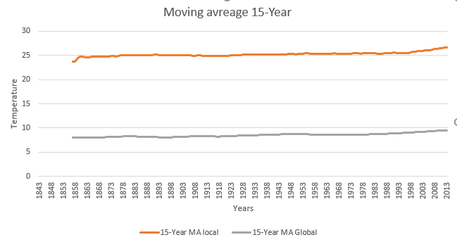

**SQL:**

Global data

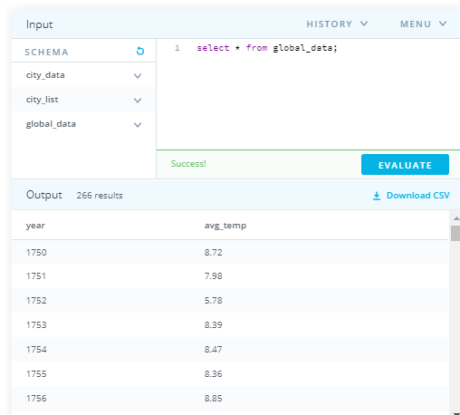

Riyadh data

